[**http://estelle.github.io/animation/30.html#slide1**](http://estelle.github.io/animation/30.html#slide1)

**CSS3 Drop Shadows**

* Creating box shadow effect

<style type="text/css">

.box{

width: 200px;

height: 150px;

background: #ccc;

box-shadow: 5px 5px 10px #999;

}

</style>

* Adding multiple box shadows to an element's box

.box{

width: 200px;

height: 150px;

background: #000;

box-shadow: 5px 5px 10px red, 10px 10px 20px yellow;

}

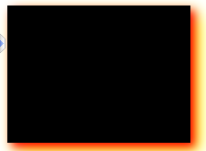

* Creating text shadow effect

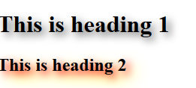

h1 { text-shadow: 5px 5px 10px #666; }

h2 { text-shadow: 5px 5px 10px red, 10px 10px 20px yellow; }

## CSS3 3D Transforms

**Moving an element in three dimensional space using the translate3d() method**

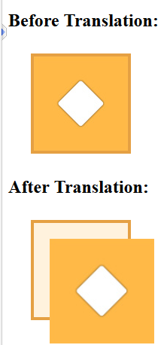

<!DOCTYPE html>

<html lang="en">

<head>

<style type="text/css">

.container{

width: 125px; height: 125px; perspective: 500px; border: 4px solid #e5a043;

background: #fff2dd; margin: 30px;

}

.transformed {

-webkit-transform: translate3d(25px, 25px, 50px); /* Chrome, Safari, Opera */

transform: translate3d(25px, 25px, 50px); /* Standard syntax */

}

</style>

</head>

<body>

<h2>Before Translation:</h2>

<div class="container">

<img src="p1.png" >

</div>

<h2>After Translation:</h2>

<div class="container">

<img src="p1.png" class="transformed" >

</div>

</body>

</html>

Rotating an element in three dimensional space using the rotate3d() method

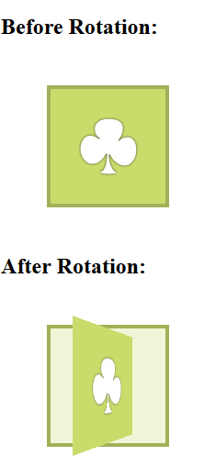

<style type="text/css">

.container{ margin: 50px; width: 125px; height: 125px; perspective: 300px;

border: 4px solid #a2b058; background: #f0f5d8; }

.transformed {

-webkit-transform: rotate3d(0, 1, 0, 60deg); /* Chrome, Safari, Opera */

transform: rotate3d(0, 1, 0, 60deg); /* Standard syntax */

}

</style>

</head>

<body>

<h2>Before Rotation:</h2>

<div class="container">

<img src="p1.png" >

</div>

<h2>After Rotation:</h2>

<div class="container">

<img src="p1.png" class="transformed" >

</div>

Scaling an element in three dimensional space using the scale3d() method

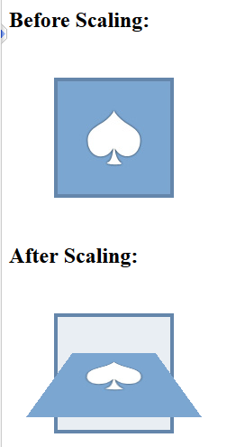

.container{

margin: 50px;

width: 125px;

height: 125px;

perspective: 300px;

border: 4px solid #6486ab;

background: #e9eef3;

}

.transformed {

-webkit-transform: scale3d(1, 1, 2) rotate3d(1, 0, 0, 60deg); /* Chrome, Safari, Opera */

transform: scale3d(1, 1, 2) rotate3d(1, 0, 0, 60deg); /* Standard syntax */

}

</style>

</head>

<body>

<h2>Before Scaling:</h2>

<div class="container">

<img src="p1.png" >

</div>

<h2>After Scaling:</h2>

<div class="container">

<img src="p1.png" class="transformed" >

</div>

Applying multiple 3D transformation to an element

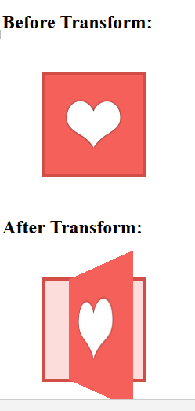

<style type="text/css">

.container{

margin: 50px;

width: 125px;

height: 125px;

perspective: 300px;

border: 4px solid #d14e46;

background: #fddddb;

}

.transformed {

-webkit-transform: translate3d(0, 0, 60px) rotate3d(0, 1, 0, -60deg) scale3d(1, 1, 2); /* Chrome, Safari, Opera */

transform: translate3d(0, 0, 60px) rotate3d(0, 1, 0, -60deg) scale3d(1, 1, 2); /* Standard syntax */

}

</style>

</head>

<body>

<h2>Before Transform:</h2>

<div class="container">

<img src="p1.jpg" >

</div>

<h2>After Transform:</h2>

<div class="container">

<img src="p1.jpg" class="transformed">

</div>

CSS3 Transitions

**Applying transition effect to background-color**

<!DOCTYPE html>

<html lang="en">

<head>

<meta charset="UTF-8">

<title>Example of CSS3 Transition</title>

<style type="text/css">

button {

color: #fff;

border: none;

padding: 10px 20px;

font: bold 18px sans-serif;

background: #fd7c2a;

-webkit-transition: background 2s; /* For Safari 3.0 to 6.0 */

transition: background 2s; /* For modern browsers */

}

button:hover {

background: #3cc16e;

}

</style>

</head>

<body>

<button type="button">Hover on me</button>

</body>

</html>

**Applying transition effect to multiple property**

<style type="text/css">

button {

color: #fff;

padding: 10px 20px;

font: bold 18px sans-serif;

background: #fd7c2a;

border: 3px solid #dc5801;

/* For Safari 3.0+ */

-webkit-transition-property: background, border;

-webkit-transition-duration: 1s, 2s;

/* Standard syntax */

transition-property: background, border;

transition-duration: 1s, 2s;

}

button:hover {

background: #3cc16e;

border-color: #288049;

}

</style>

## CSS3 Animations

**Animating elements on a web page**

<!DOCTYPE html>

<html lang="en">

<head>

<meta charset="UTF-8">

<title>Example of CSS3 Translate Animation</title>

<style type="text/css">

.box {

margin: 50px;

width:153px;

height:103px;

background: url("p1.png") no-repeat;

position: relative;

/* Chrome, Safari, Opera */

-webkit-animation-name: moveit;

-webkit-animation-duration: 2s;

/* Standard syntax */

animation-name: moveit;

animation-duration: 2s;

}

/* Chrome, Safari, Opera */

@-webkit-keyframes moveit {

from {left: 0;}

to {left: 50%;}

}

/* Standard syntax */

@keyframes moveit {

from {left: 0;}

to {left: 50%;}

}

</style>

</head>

<body>

<div class="box"></div>

</body>

</html>

**Defining keyframe while creating animations**

<!DOCTYPE html>

<html lang="en">

<head>

<meta charset="UTF-8">

<title>Example of CSS3 Shake Animation</title>

<style type="text/css">

.box {

margin: 50px;

width:120px;

height:110px;

background: url("p1.png") no-repeat;

position: relative;

left: 0;

/* Chrome, Safari, Opera */

-webkit-animation-name: shakeit;

-webkit-animation-duration: 2s;

/* Standard syntax */

animation-name: shakeit;

animation-duration: 2s;

}

/* Chrome, Safari, Opera */

@-webkit-keyframes shakeit {

12.5% {left: -50px;}

25% {left: 50px;}

37.5% {left: -25px;}

50% {left: 25px;}

62.5% {left: -10px;}

75% {left: 10px;}

}

/* Standard syntax */

@keyframes shakeit {

12.5% {left: -50px;}

25% {left: 50px;}

37.5% {left: -25px;}

50% {left: 25px;}

62.5% {left: -10px;}

75% {left: 10px;}

}

</style>

</head>

<body>

<div class="box"></div>

</body>

</html>

**Setting all animation properties at once - The animation shorthand property**

<!DOCTYPE html>

<html lang="en">

<head>

<meta charset="UTF-8">

<title>Example of CSS3 Infinite Translate Animation</title>

<style type="text/css">

.box {

margin: 50px;

width:103px;

height:130px;

background: url("p1.png") no-repeat;

position: relative;

/* Chrome, Safari, Opera */

-webkit-animation: repeatit 2s linear 0s infinite alternate;

/* Standard syntax */

animation: repeatit 2s linear 0s infinite alternate;

}

/* Chrome, Safari, Opera */

@-webkit-keyframes repeatit {

from {left: 0;}

to {left: 50%;}

}

/* Standard syntax */

@keyframes repeatit {

from {left: 0;}

to {left: 50%;}

}

</style>

</head>

<body>

<div class="box"></div>

</body>

</html>

**CSS3 Gradients**

**Creating linear gradients from top to bottom direction**

<!DOCTYPE html>

<html lang="en">

<head>

<title>Example of Linear Gradients from Top to Bottom</title>

<style type="text/css">

.gradient {

width: 400px;

height: 300px;

/* Fallback for browsers that don't support gradients */

background: red;

/* For Safari 5.1 to 6.0 */

background: -webkit-linear-gradient(red, yellow);

/* For Internet Explorer 10 */

background: -ms-linear-gradient(red, yellow);

/* Standard syntax */

background: linear-gradient(red, yellow);

}

</style>

</head>

<body>

<div class="gradient"></div>

</body>

</html>

**Repeating the linear gradients**

<!DOCTYPE html>

<html lang="en">

<head>

<title>Example of Repeating the Linear Gradients</title>

<style type="text/css">

.gradient {

width: 400px;

height: 300px;

/* Fallback for browsers that don't support gradients */

background: white;

/* For Safari 5.1 to 6.0 */

background: -webkit-repeating-linear-gradient(black, white 10%, lime 20%);

/* For Internet Explorer 10 */

background: -ms-repeating-linear-gradient(black, white 10%, lime 20%);

/* Standard syntax */

background: repeating-linear-gradient(black, white 10%, lime 20%);

}

</style>

</head>

<body>

<div class="gradient"></div>

</body>

</html>

**Creating radial gradients**

<!DOCTYPE html>

<html lang="en">

<head>

<title>Example of Radial Gradients</title>

<style type="text/css">

.gradient {

width: 400px;

height: 300px;

/* Fallback for browsers that don't support gradients */

background: red;

/* For Safari 5.1 to 6.0 */

background: -webkit-radial-gradient(red, yellow, lime);

/* For Internet Explorer 10 */

background: -ms-radial-gradient(red, yellow, lime);

/* Standard syntax */

background: radial-gradient(red, yellow, lime);

}

</style>

</head>

<body>

<div class="gradient"></div>

</body>

</html>

**Setting the shape of radial gradients**

<!DOCTYPE html>

<html lang="en">

<head>

<title>Example of Setting the Shape Radial Gradients</title>

<style type="text/css">

.gradient {

width: 400px;

height: 300px;

/* Fallback for browsers that don't support gradients */

background: red;

/* For Safari 5.1 to 6.0 */

background: -webkit-radial-gradient(circle, red, yellow, lime);

/* For Internet Explorer 10 */

background: -ms-radial-gradient(circle, red, yellow, lime);

/* Standard syntax */

background: radial-gradient(circle, red, yellow, lime);

}

</style>

</head>

<body>

<div class="gradient"></div>

</body>

</html>

**Setting the size of radial gradients**

<!DOCTYPE html>

<html lang="en">

<head>

<title>Example of Setting the Size Radial Gradients</title>

<style type="text/css">

.gradient {

width: 400px;

height: 300px;

/* Fallback for browsers that don't support gradients */

background: red;

/* For Safari 5.1 to 6.0 */

background: -webkit-radial-gradient(left bottom, circle farthest-side, red, yellow, lime);

/* For Internet Explorer 10 */

background: -ms-radial-gradient(left bottom, circle farthest-side, red, yellow, lime);

/* Standard syntax */

background: radial-gradient(circle farthest-side at left bottom, red, yellow, lime);

}

</style>

</head>

<body>

<div class="gradient"></div>

</body>

</html>

**Repeating the radial gradients**

<!DOCTYPE html>

<html lang="en">

<head>

<title>Example of Repeating the Size Radial Gradients</title>

<style type="text/css">

.gradient {

width: 400px;

height: 300px;

/* Fallback for browsers that don't support gradients */

background: white;

/* For Safari 5.1 to 6.0 */

background: -webkit-repeating-radial-gradient(black, white 10%, lime 20%);

/* For Internet Explorer 10 */

background: -ms-repeating-radial-gradient(black, white 10%, lime 20%);

/* Standard syntax */

background: repeating-radial-gradient(black, white 10%, lime 20%);

}

</style>

</head>

<body>

<div class="gradient"></div>

</body>

</html>